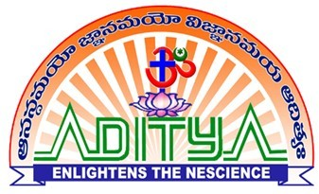
ADITYA COLLEGE OF ENGINEERING :: SURAMPALEM
FACULTY PROFILE
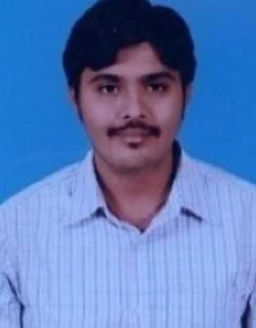Personal Profile Name N JASWANTH
Date of Birth 23-03-1992
Address Department of EEE,
Aditya College of Engineering, Surampalem-533437
East Godavari District, Andhra Pradesh
Date of Joining 05-06-2021
Vidwan profile | https://vidwan.inflibnet.ac.in/profile/382709

Academic Profile
Qualification | Name of the Board/University | Year of Passing
B.Tech | ADITYA ENGINEERING COLLEGE | 2013
M.Tech. | HELAPURI Inst. Of Tech and Science | 2016
Ph.D.
Others
Professional Experience
Designation | Name of the Employer | Length of Service
 | Aditya College of Engineering | Till Date

Life long membership in MISTE
Memberships of Professional Societies:

Research Publications
National  Conference | International  Conference | National  Journals | International  Journals | Books / Book  Chapters | Patents
Seminars/ Workshop/ FDPs attended
Seminars | Workshops | FDPs
4 | 2 | 2
NPTEL FDPs / Professional Certification
NPTEL | Coursera | Udemy | Others
 | 1

Other Information
2)
1)

